**Investment Analytics**

**Architecture Design**

**Revision Number - 1.1**

**Last Date of Revision - 24/09/2022**

**Arzoo Meshram**

**Document Control**

| DATE | VERSION | DESCRIPTION | OWNER |
| --- | --- | --- | --- |
| 2nd Sept 2022 | 1.0 | Introduction,  Architecture,  Deployment | Arzoo Meshram |
| 24th Sept 2022 | 1.1 | Final Revision | Arzoo Meshram |

**Contents**

Document Version Control…………………………………………………………………………2

1. Introduction……………………………………………………………………………………….4

1.1 What is an Architecture Design Document? 4



1.2 Scope……………………………………………………………………………………

1. Architecture……….……………………………………………………………………….……...

2.1 PowerBi Architecture………………………………………………………………….

2.2 Components of PowerBiArchitecture……………………………………………….

Deployment……….……………………………………………………………………….……...

3.1 PowerBiDeployment………………………………………………………………….

3.2 Publish datasets and reports from PowerBi………………………………



**1. Introduction**

**1.1 What is an Architecture Design Document?**

Any software needs the architectural design to represent the design of the software. IEEE defines architectural design as “the process of defining a collection of hardware and software components and their interfaces to establish the framework for the development of a computer system.” The software that is built for computer-based systems can exhibit one of these many architectures.

Each style will describe a system category that consists of:

* A set of components (eg: a database, computational modules) that will perform a function required by the system.
* The set of connectors will help in coordination, communication, and cooperation between the components.
* Conditions that how components can be integrated to form the system.
* Semantic models help the designer to understand the overall properties of the system.

**1.2 What is Scope?**

Architecture Design Document (ADD) is an architectural design process that follows a step-by-step refinement process. The process can be used for designing data structures, required software architecture, source code and ultimately, performance algorithms. Overall, the design principles may be defined during requirement analysis and then refined during architectural design work.



**2. Architecture**

**2.1 PowerBi Architecture**

Power BI can extract data from multiple sources and provide custom visualization. It also provides real-time analytics on both structured and unstructured data for different devices.

Power BI desktop app is used to create reports, while Power BI Services (Software as a Service - SaaS) is used to publish the reports, and Power BI mobile app is used to view the reports and dashboards.

MS Power BI architecture consists of four major steps that explain the whole process from data sourcing to the creation of reports and dashboards. Various technologies and processes work together to get the required results with extreme precision.

Let’s see those steps further :

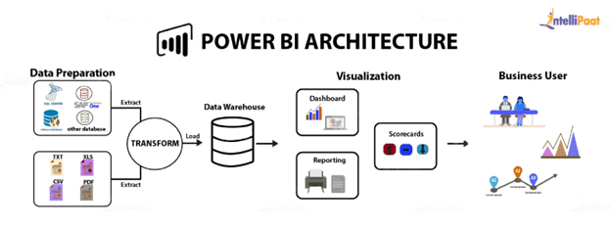

* **Sourcing data**: Power BI extracts data from various servers, Excel sheets, CSV files, and databases. The extracted information can be directly imported to Power BI, or a live service link is established to receive it. If you directly import the data in Power BI, it will only be compressed up to 1 GB. Post that, you can only run live queries on your chunky datasets.
* **Transforming the data**: Before visualizing the data, cleaning and preprocessing it should be done. This means removing useless or missing values from rows or columns. Following that, certain rules will be applied to transform and load the datasets into the warehouse.
* **Report and publish**: After cleaning and transforming the data, reports will be created based on requirements. A report is a visualization of the data with different filters and constraints presented in the form of graphs, pie charts, and other figures.
* **Creating dashboards**: Power BI D[ashboards](https://intellipaat.com/blog/power-bi-dashboard/) are created by pinning individual elements or pages of live reports. Dashboards should be created after you have published your reports to the BI service. When the reports get saved, the visual maintains the filter settings chosen so that the user can apply filters and slicers.

## **2.2 Components of Power BI Architecture**

Below are the major Power BI components of Power BI platform architecture that play an important role to implement the BI capabilities offered by the tool.

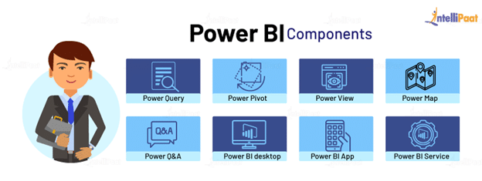

1. **Power BI Desktop:** Power BI Desktop is a free software used to convert, connect, and visualize datasets on a PC or laptop. It’s one of the most important Power BI components where you can integrate distinct information sources and combine them to form a data model. Then, you can create graphics or image collections to share them as records with other individuals in your organization.
2. **Power BI Service:** After the reports are created on Power BI Desktop, you can publish them on the cloud using Power BI Service. The service connects users and allows them to create dashboards known as Power BI Workspace. It offers natural language Q&A and alerts, and it is available in both Power BI free and Power BI Pro versions.
3. **Power BI Mobile Apps:** The mobile apps of Power BI keep you connected with the data no matter where you are. You can see live reports and dashboards on your iOS and Android smartphones and make better market decisions on the go. Only pro Power BI architecture provides the feature of Mobile reports and dashboards.
4. **Power BI Query:** Power Query allows users to connect distinct information from multiple sources and convert them to satisfy their business requirements.
5. **Power Q&A:** Power Q&A allows business users to explore information in their own words and phrases. This natural language question and reply engine is the fastest way to get the response from your data.
6. **Power Map:** Power BI queries offer a 3D visualization tool, Power Map, that shows differences in your datasets with shadings ranging from dark to light.
7. **Power Pivot:** Power Pivot allows data storage with high compression, quick aggregation, and calculation. With Power Query, users can load information into it, or the pivot can load information on its own.
8. **Power View:** For a quick and effective visualization in your Excel workbooks, you can try Power View’s drag-n-drop feature and save your time. It’s an important part of MS Power BI architecture that enables the user to quickly visualize the data in a few clicks.

**3. Deployment**

**3.1 PowerBi Deployment**

Nowadays, Data is everything. Data Visualization brings data to life. Everyone is collecting data and most likely analyzing just a portion of it to solve business problems, gain competitive advantages, and drive enterprise transformation. With the explosive growth of enterprise data, database technologies, and the high demand for analytical skills, today’s most effective IT organizations have shifted their focus to enabling self-service by deploying and operating PowerBi at scale, as well as organizing, orchestrating, and unifying disparate sources of data for business users and experts alike to author and consume content.

Year Wise Analysis :

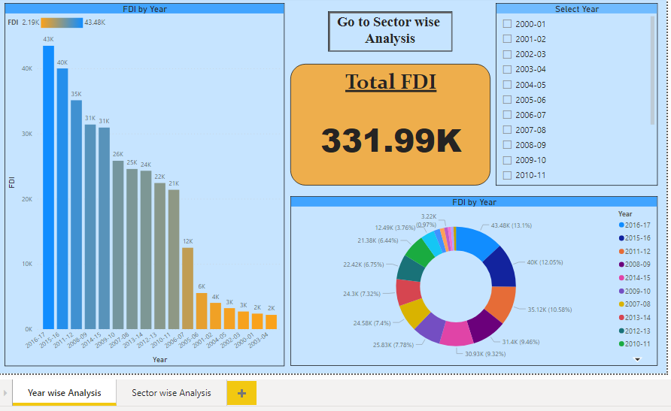

Sector wise Analysis :

